

Lab 1: Creating an ER Diagram

SC2207 - Introduction to Databases

**SCSY Team 5**

| **Name** | **Matriculation Number** |
| --- | --- |
| Gauthaman Ramya Varshini | U2123023K |
| Pearlina Tan Qinlin | U2221690F |
| Chin Ao-Wen | U2240595B |
| Tan Jie Ning, Jolynn | U2220577B |
| Sum Yuan Sen | U2221346D |
| Vilan Chan | U2020092L |

**ER Diagram**

Link to Clearer Image: [ER Diagram](http://tinyurl.com/yerktuyy)

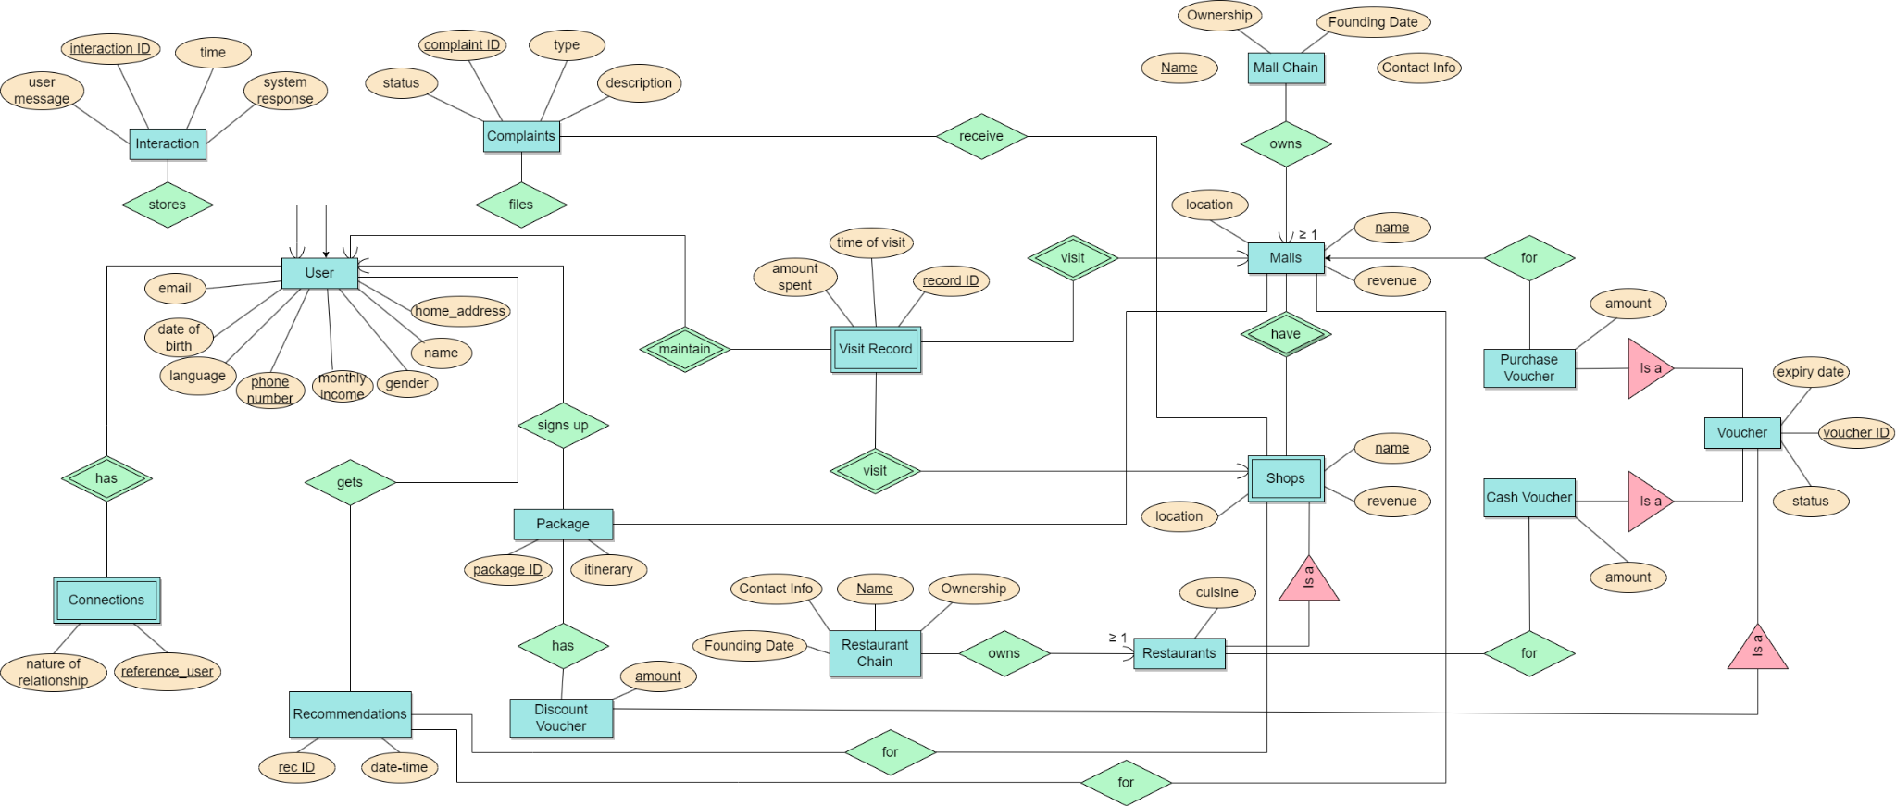

**ER Diagram Description**

There are 16 entity sets to satisfy the requirements of Appendix A. The keys are underlined among multiple attributes.

1. **User**

Attributes: Phone Number, Name, Language, Gender, Date of Birth, Email, Home Address, Monthly Income

Relationship: Many-to-one relationship to Interaction, Complaints and Package entities, weak entity set to Visit Record entity set

1. **Interaction**

Attributes: InteractionID, Time, User Message, System Response

Relationship: Many-to-one relationship to User Entity

1. **Complaints**

Attributes: ComplaintID, Type, Status, Description

Relationship: Many-to-one relationship to User Entity, Each user may have multiple complaints, but each complaint can only be for user

1. **Visit Record**

Attributes: RecordID, Time of Visit, Amount Spend

Relationship: Weak entity set to User, Malls, and Shops Entity Set

1. **Mall Chain**

Attributes: Name, Contact Info, Founding Date, Ownership

Relationship: Owns Mall, must own at least 1 mall (Degree Constraint)

1. **Malls**

Attributes: Name, Location, Revenue

Relationship:

a) Many-to-many relationship to Shops Entity, a mall can have multiple shops, and a shop can be in multiple malls

b) Many-to-one relationship to Purchase Voucher, a mall can have multiple Purchase Vouchers, but a Purchase Voucher is only for one mall

1. **Shops**

Attributes: Name, Location, Revenue

Relationship: A weak entity set to Malls Entity, Shops Entity requires Malls Entity’s attribute to clearly define the location of the shop. The composite key will be (Malls Name, Shops Name)

1. **Restaurant Chain**

Attributes: Name, Contact Info, Founding Date, Ownership

Relationship: Owns Restaurant, must own at least 1 restaurant (Degree Constraint)

1. **Restaurants**

Attributes: Cuisine

Relationship: Subclass to Shops Entity, Inherit key Name from Shops Entity

1. **Voucher**

Attributes: VoucherID, Expiry Date, Status

Relationship: Superclass to Purchase Voucher, Cash Voucher, and Discount Voucher entities

1. **Purchase Voucher**

Attributes: Amount

Relationship: Subclass of Voucher Superclass, Inherits key VoucherID from Voucher Entity

1. **Cash Voucher**

Attributes: Amount

Relationship: Subclass of Voucher Superclass, Inherits key VoucherID from Voucher Entity

1. **Discount Voucher**

Attributes: Amount

Relationship: Many-to-many relationship with Package Entity

1. **Package**

Attributes: PackageID, Itinerary

Relationship: Many-to-many relationship with Discount Voucher Entity

1. **Recommendations**

Attributes: RecID, Date-Time

Relationship: Many-to-many relationship with User, Shops, and Malls entities.

1. **Connections**

Attributes: Reference_user (defined by other user’s hp number), Nature of Relationship

Relationship: Weak entity set to User, Need User Entity to clearly define the relationships between users

**Assumptions**:

1. Visit record is automatically recorded when the user visited the mall
2. Mall shops and restaurants report their revenue (collected from app users) to the app
3. Each shop/restaurant is unique in the mall it is located in (i.e. no 2 shops/restaurants have the same name in the same mall)
4. Mall name is unique
5. Vouchers are mall-specific (each voucher can only be used at a specific mall)
6. Users can make online payment to shops using the app
7. Calculations for the highest earning is based on users who pay through the app
8. Only 1 type of relationship between any 2 users will be recorded (i.e. User A is User B’s father, disregarding other relationships which may include Instagram followers, etc.)
9. Not every user gets a recommendation

**APPENDIX C: INDIVIDUAL CONTRIBUTION FORM**

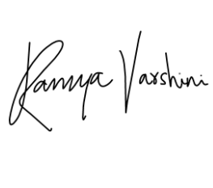

| **Full Name** | **Individual Contribution to Lab 1 Submission** | **Percentage of Contribution** | **Signature** |
| --- | --- | --- | --- |
| Gauthaman Ramya Varshini | Helped sketch the ER diagram. Digitalised the diagram to improve readability. Helped identify necessary identities and relationships. | 16.67% |  |
| Pearlina Tan Qinlin | Contributed to the initial planning of the draft and actively participated by providing input to enhance the diagram. | 16.67% |  |
| Chin Ao-Wen | Contributed ideas through active discussion | 16.67% |  |
| Tan Jie Ning, Jolynn | Contributed to the initial planning of the draft and actively provided input and suggestions to enhance the diagram and description | 16.67% |  |
| Sum Yuan Sen | Actively contributed in both draft and final diagram | 16.67% |  |
| Vilan Chan | Actively contributed in refining ER diagram, adding word description | 16.67% |  |

**APPENDIX D: USE OF AI TOOL(S) IN LAB WORK**

Each team member should indicate either A or B:

A. I affirm that my contribution(s) to the lab work is my own, produced without help from any AI tool(s).

B. I affirm that my contribution(s) to the lab work has been produced with the use of AI tool(s).

| Team member (full name) | Signature | Date | A or B |
| --- | --- | --- | --- |
| Gauthaman Ramya Varshini |  | 5/2/24 | A |
| Pearlina Tan Qinlin |  | 5/2/24 | A |
| Chin Ao-Wen |  | 5/2/24 | A |
| Tan Jie Ning, Jolynn |  | 5/2/24 | A |
| Sum Yuan Sen |  | 5/2/24 | A |
| Vilan Chan |  | 5/2/24 | A |

By signing this form, you declare that the above affirmation made is true and that you have read and understood NTU’s policy on the use of AI tools.

If any team member answered B, the team member(s) must indicate and replicate the table below for every instance AI tool(s) is used:

| Name of AI tool | < For example, ChatGPT > |
| --- | --- |
| Input prompt | < Insert the question that you asked ChatGPT > |
| Date generated |  |
| Output generated | < Insert the response verbatim from ChatGPT > |
| Output screenshots |  |
| Impact on submission | < Briefly explain which part of your submitted work was ChatGPT’s  response applied > |